Preliminary Design Review
Sandia Clinic 2008

Chris Chadwick
Eric Hsu
Michael Stevens
Rashin Bolkameh
Dan Rolfe
Professor Charles
Introduction

The Global Positioning System (GPS) is a fully functional Global Navigation Satellite System (GNSS). It uses dozens of satellites that transmit microwave signals that enable receivers to determine their current location. The satellites continuously transmit the time, a precise orbit for the satellite sending the message, and the general system health and rough orbits of all GPS satellites. The receivers then use this information to calculate their position. In order to calculate position the receiver must receive a signal from at least four satellites. Four satellite signals are necessary to calculate latitude, longitude, altitude, and to account for any time variance in the receiver.

The goal of this project is to place a chip with a GPS receiver, to calculate position, on the Sandia NESDAC stack. Because the stack is powered by two CR2 batteries and it should operate for weeks at a time, a major concern of the project is to minimize the power consumption. There are several ways that power consumption will be significantly lower than a personal GPS receiver. While most GPS receivers require a full signal from the satellites (about 30-40s), one goal of this project is to calculate position with less than one second of data. This can be accomplished by accessing a database of GPS information knowing the exact time that the signal was sent. Another way the power consumption will be lowered is to use an accelerometer to only activate the receiver when the chip is moving.

Overview of the project

Working in partnership with Sandia National Labs, a low power GPS stack will be constructed for the NESDAC that is able to capture a short sample of the GPS satellite signal and store these data into 1 to 2GB flash memory. The project has certain design requirements that need to be followed:
• Must run off two CR2 batteries.
• Must be able to stay on location for weeks.
• Must interconnect with the current stack.

In order to meet these design requirements, the stack unit must be designed with the space and power requirements in mind.

Design Decisions

Phase 1:
GPS Front-End Receiver Module - Rakon GRM8650 or SiGe SE4120L
Antenna GPS Chip-Scale
Flash Memory 2GB
Accelerometer ADXL330
uProcessor TI-MSP430
Mini-USB Connection
Geotate or MATLAB to process data then Google Earth to plot coordinates

First phase of design was based on using a GPS front end receiver module to capture GPS signal to flash memory utilizing a micro processor. Once the data is saved into the flash, we would then use USB to process the data using Geotate or MATLAB.
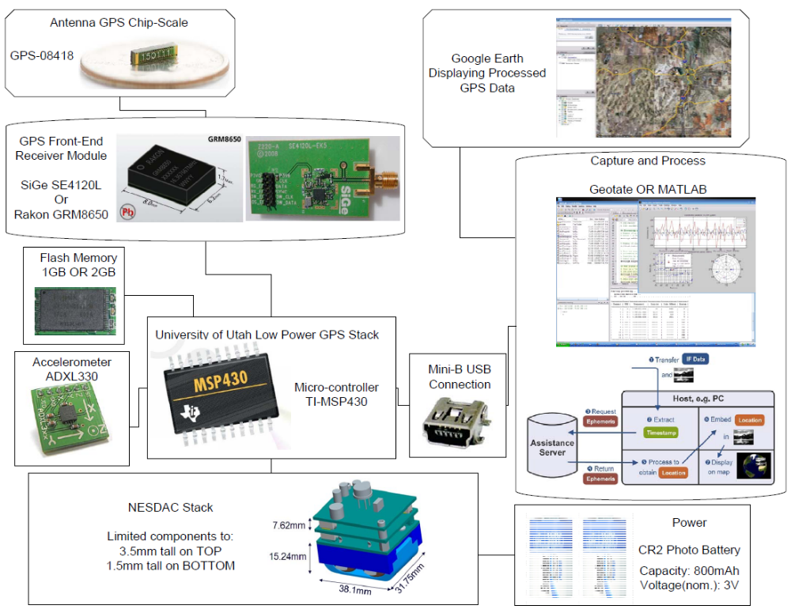

Problems: USB controller was very complicated to implement, decision on saving 600MB or 128KB of data, GPS data saving issues.

Phase 2:
GPS Front-End Receiver Module - Rakon GRM8650 or SiGe SE4120L
Antenna GPS Chip-Scale
uSD Flash Memory
Accelerometer ADXL330
uProcessor TI-MSP430
Geotate or MATLAB to process data then Google Earth to plot coordinates

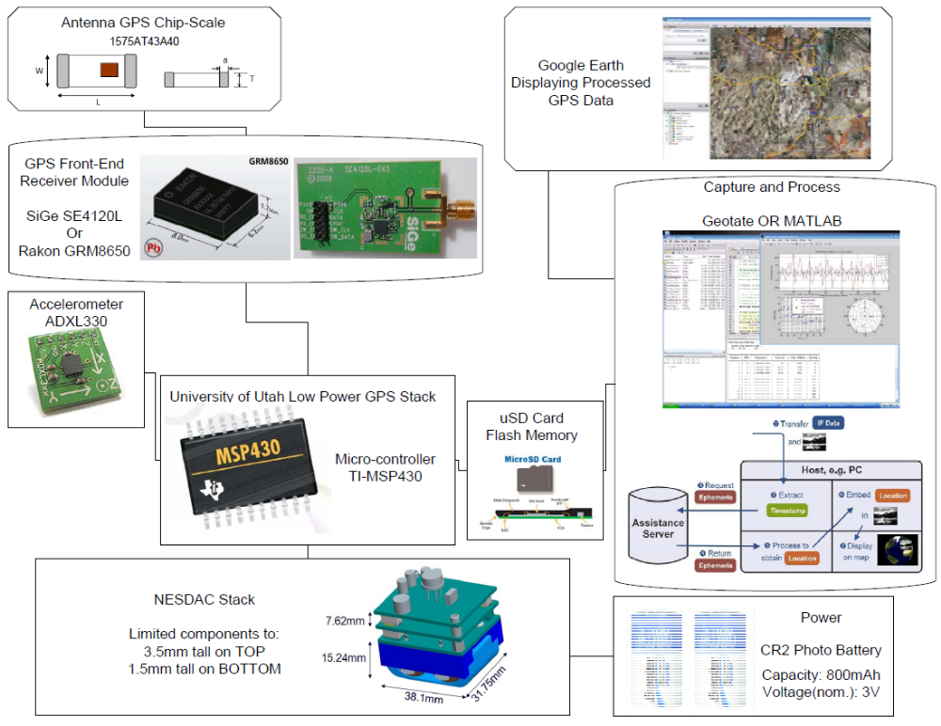

In the second phase, we made the decision of just acquiring 128KB of GPS data versus 600MB. Since the USB controller was hard to implement, we switched to micro SD flash memory interface.

Problems: Large amount of data requires faster and stronger micro processor which defeats the use of low power micro processor. Micro SD interface is not open source information.

Phase 3:
Antenna GPS Chip-Scale
GPS Front-End SiGe SE4120L
Accelerometer ADXL330
uProcessor TI-MSP430
Serial Flash Memory
Serial Output

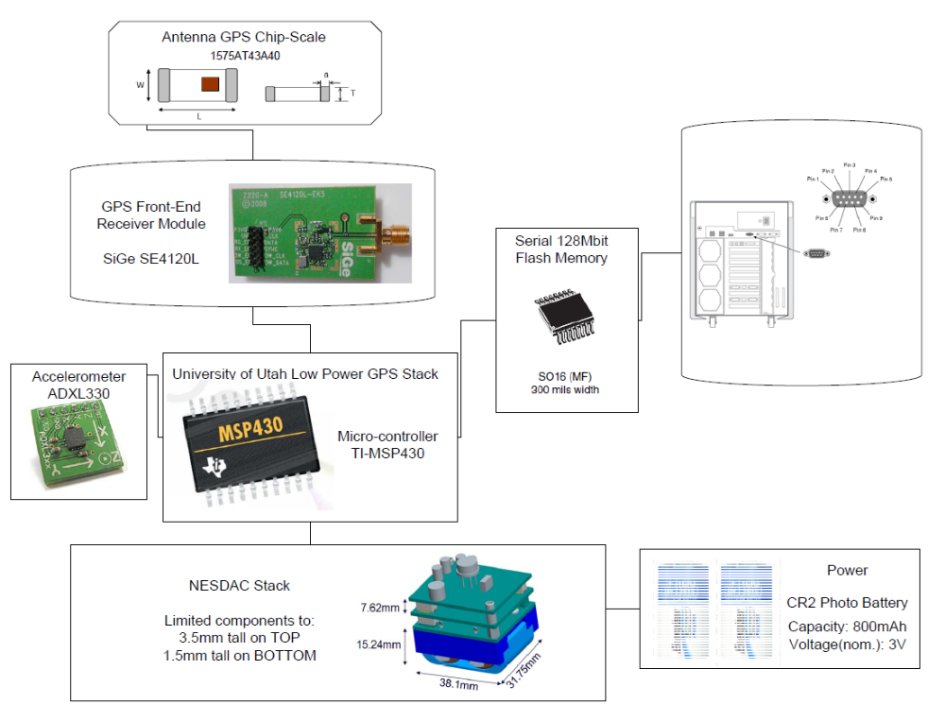

In the third phase we switch the flash memory to serial flash since flash memory writes in BLOCK and serial flash accepts data in SPI which the micro processor uses. Since we switch to acquiring 128KB of data, MATLAB could not process the data. Geotate Software Company was not willing to help us unless there were a business transaction between them and us. For our project, we decided that the software processing of the data was too complicated for the timeline.

Some of the current design decisions:
• The design will be using one low power MSP micro controllers from TI.
• In order to limit power consumption, 1 or 2 GB of flash memory will be used.
• To allow communication for process on a computer, a mini-B USB port will be utilized.
• An accelerometer will be incorporated for motion sensitive power management.
• Either a SiGe or Rakon GPS front end receiver module.
• A small, slim GPS antenna.

The Debate on the GPS device

The original design decision was to essentially reverse engineer the SiGe USB GPS device, modifying some of its design to fit the Sandia application. While conducting research on this method, it was discovered that the current Matlab code requires a very large amount of data (600+ MB) to calculate GPS location properly. Without a more efficient Matlab code this design will not be practical. Considering the manpower allocated to the project as well as the time limitations it would likely be best to avoid writing new code to process the data.

One possible alternate software solution is currently under development by Geotate. Geotate has a Capture and Process software which can calculate location and only requires 128 kB of capture information per 0.2sec. This would be a vast improvement over the currently required 600+ MB of capture information. There are still some unknowns with this solution.
• The software is still in R&D, it is unclear if it will be available in time for use with this project.
• Currently the software is only said to work with a select number of Rakon GPS units.
• It is unknown if the software will work with the SiGe GPS.
With the information currently available a definite selection of the GPS unit will be postponed until more answers are obtained as well as the way we will process the data.

Fitting the GPS onto the stack

The dimensions for the device have already been decided, the total size of the board is 38mm by 32mm. There must be space for everything needed for the GPS along with the board interconnect and structural components. If needed the GPS module can take up two consecutive modules on the stack, but this will add additional complexity to the project that would rather be avoided.

Writing to Memory

While looking into writing to memory the first idea was to use the micro controller as a medium between the GPS chip and the flash. This design became a potential problem; the maximum clock speed for the MSP micro controller is 8 MHz which is less than half of the output speed of the GPS receiver. In order to solve the clock speed problem, a different design was developed. The new design for this part of the project will now attempt to write directly from the GPS to the flash. The micro controller will still be used to coordinate between the two devices, but will not be used as a buffer between the chips. The intended design will look similar to figure 1.
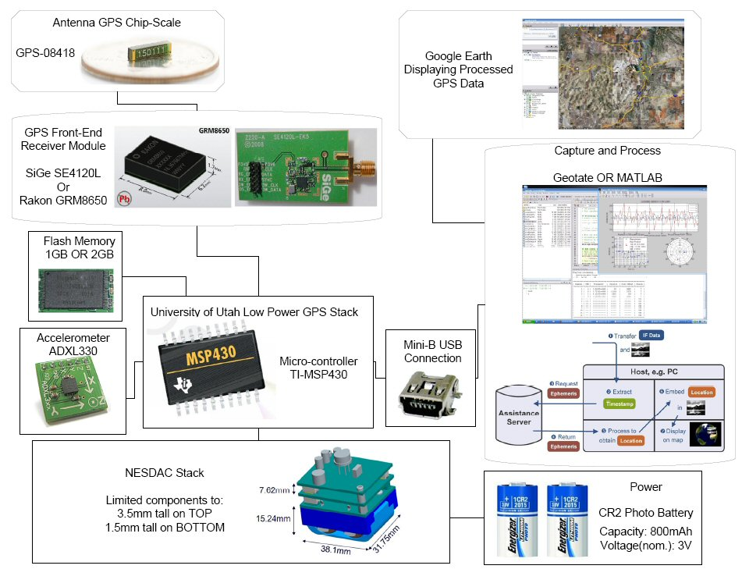
Figure 1

GPS

The GPS radio consists of:
• A low noise amplifier, matched to the antenna.
• A SAW filter to remove strong out of band interfering signals.
• A receiver integrated circuit, which mixes the incoming GPS radio signal to a low intermediate frequency, filters it, and samples it with an ADC to produce a bit stream of the IF signal
• A temperature controlled crystal oscillator, used for the oscillator in order to provide sufficient temperature stability, despite variations in ambient and device temperature.

Radio module

For our applications minimum size is an important requirement. As there is no baseband processor in our GPS module the radio can be made very small. We will use either a Rakon GRM8650 or a SiGe SE4120L GNSS. These compact units provide all the required GPS front-end functionality in a small package, including GPS radio receiver, filtering, and oscillator TCXO, ready-tested.

Notes:

After sending an update to Adrian he suggested that we try to use the DMA on the micro controller to achieve the write speeds needed. This approach will be looked into in our next meeting

Risks

We were planning to use the Matlab program for our project but so far we have not been able to calculate the position by using the Matlab code for GPS capture times, under 38 seconds (630 MB). Therefore, we came across an idea of using the Geotate software over the Matlab code, which can give a GPS location with only 128 kB of information. It seems to be a lot faster if we could be able to use the Geotate software instead. The Geotate software takes the captured GPS data and calculates a position fix (latitude, longitude, altitude, time). Using optimized algorithms a first fix is computed in only 1-2s. Once a good estimate of the data locations is known, subsequent fixes are computed in a fraction of a second.

Although, there are some points that we need to look into and be sure before we make our final decisions. First, we need to figure out when the software will be released and are we going to be able to receive the software on time, so we can use it for our project?
And last it must be determined if the software would work with the SiGe chip when released? And if the SiGe chip can’t be used with the Geotate software, can one of the Rakon chip be used, instead?

Project Milestones

This section will look at how the group, will manage its time to complete the project in our given time frame. The major parts to the project that still need to be accomplished are, design of the board, programming of the micro controller, construction of the board, testing of the board, and getting the data properly working with the software.

The first major milestone is design and construction of the board for the stack. This will take up the most of our time, so it is really important that the time spent on this portion is well managed. The plan is to try to have the board designed by the end of December. This way it can be fabricated by the time that spring semester starts. This will allow for time to test the board and if necessary make any changes to the board and have another one fabricated.

Also the programming of the micro controller can be done when the board is being designed. That way when the board is fabricated it can be tested afterwards. Once the board is working the board needs to be test with the software that is chosen to calculate the GSP coordinates. This testing needs to be completed by the first part of March, because then the final report needs to be written before the senior project is due. A table of tasks and their estimated completion dates can be seen in table 1.

Task | Tentative Completion Date
Board Design | December 15, 2008
Program Microcontroller | January 12, 2009
Testing | February 28, 2009
Project Completion | March 6, 2009
Report and Presentation | March 24, 2009
Table 1

Conclusion

The use of GPS to determine position has become increasingly popular over the years. In coordination with Sandia National Labs, a chip will be designed and built to calculate position and it will work with the NESDAC stack. The chip will have a microcontroller, antenna, GPS receiver, accelerometer, flash memory, and a USB controller. The antenna and receiver will be used to acquire signals from GPS satellites. The information will be stored in the flash memory. The accelerometer will be used for activating the receiver. The chip will then be able to be connected to a PC and the stored information downloaded. The goal is to be able to calculate the positions stored on the chip using only approximately 128 kB samples of the acquired data. If that proves to be unfeasible, then position will be calculated using 600+ MB samples of the data. However, that would not be the optimal solution because the flash memory would then only be able to store 2-3 samples. A complete design will be completed by the end of December and the chip will be fabricated and tested before next March.

